Khuzaima Mushtaq  
CSS 432

**Program 1: Intro to Network Programming**

My program follows the guide in the assignment very closely. I use the recommended socket code for setting up and connecting my sockets. In client, I use the args to set up my local variables then set up a socket connection to the proper port and server host provided in args. Once the connection is established, based on the test scenario type (1, 2, or 3) I write to the clientSd, number of repetition times. Then I read back from the server the number of times it used the call read. I use gettimeofday to keep track of how long it takes to send all the data and then how long it takes for the server reply to get back. In server, I use the args to get the number of repitiontions to call read and the port number to listen on. I set up the socket and listen for connections. When a connection is spawned I take the socket descriptor for that connection, create a new thread and pass the SD into it, where that connection is handled. When a new thread is spawned I get the SD from the parameter passed in, then I create a buffer size 1500 as specified. Then I read from the socket repetition times and keep track of how much time it takes to read everything, and how many times read is called. Then I output the time it took to read to screen and write back to the socket the number of times read was called, which is then read from the client.

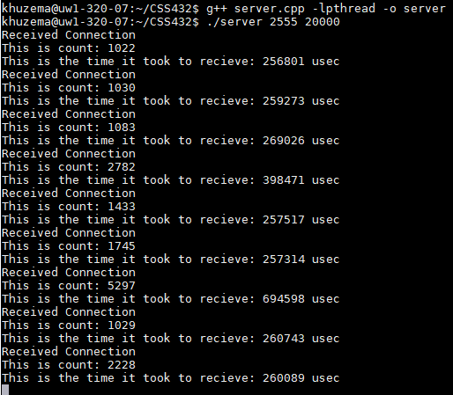**EXECUTION OUTPUT:**

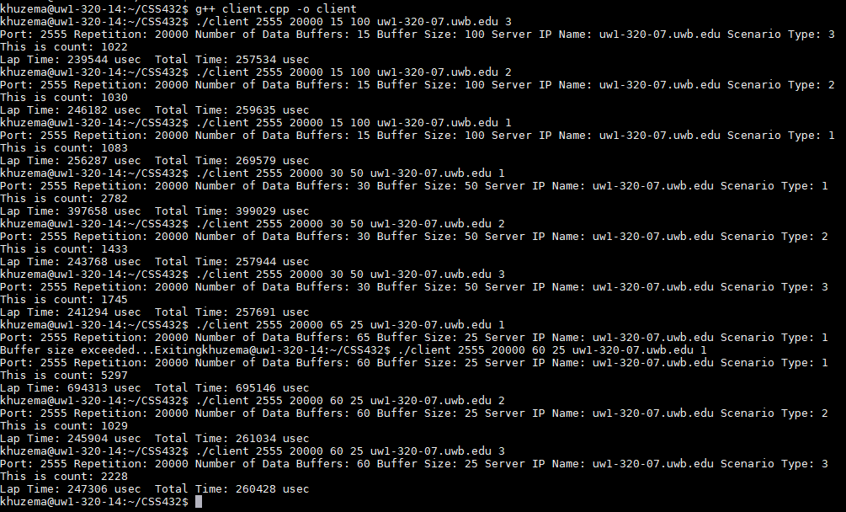

**PERFORMANCE EVALUATION:**

|  |  |  |  |  |  |
| --- | --- | --- | --- | --- | --- |
| **Repetition** | **nbuf** | **bufsize** | **Type 1** | **Type 2** | **Type 3** |
| 20000 | 15 | 100 | count:1083  LapTime:256287  TotalTime:269579 | count:1030  LapTime:246182  TotalTime:259635 | count: 1022  LapTime: 239544 usec  TotalTime:257534 usec |
| 20000 | 30 | 50 | count: 2782  LapTime: 397658  TotalTime:399029 | count: 1433  LapTime: 243768  TotalTime:257944 | count: 1745  LapTime: 241294 usec  TotalTime:257691 usec |
| 20000 | 60 | 25 | count: 5297  LapTime: 694313  TotalTime:695146 | count: 1029  LapTime: 245904  TotalTime:261034 | count: 2228  LapTime: 247306 usec  TotalTime:260428 usec |

**DISCUSSION:**

This results would be different when using a slower network especially in terms of the difference between TotalTime and LapTime. I think count ie. The number of times read is called would still be the same and the data would be read in similar chunks since we are using a small size buffer of 1500 bytes. Overall, the time it takes to complete the same actions would be slower but the biggest difference will be noticeable in the Total Time. Between the different test cases however, Type 1 would be affected the least by a slower connection since it makes multiple writes and sends smaller chunks of data individually which can travel as needed on a slower network. Type 3, on the other hand, sends all data in a single write, and on a slower network this has a chance of causing packet loss due to buffer overload if the data being sent exceeds that capacity and also might max out the bandwidth on a slower connection. In the case of Type 2, which sends all the data in the form of a iovec, the downside would be similar to Type 3. Additionally, we want to use multiple threads to handle separate connections because that way our server can handle multiple connections as a server should be able to do, This also makes it so that each connection is a separate entity and has its own line of execution thereby not messing up different connections as it might if it was not multi-threaded. This also allows us to put our server is a while loop forever and still have it be able to service new threads without needing multiple variables for expected connections.